
\r

GUIDELINES
PR2
E-curriculum in Language Learning for Teachers

What abilities should a virtual teacher possess? What traits and abilities are required to offer online training?

Teachers interested in a career in e-learning must examine two major changes in the teaching profession: their role and technique.

They now serve as facilitators instead than lecturers, which is no longer their primary goal. This suggests the creation of collaborative learning environments in which everyone participates.

It is obvious that a qualified teacher already has the information and methodology necessary to instruct a class. However, they must make sure that they acquire the abilities necessary to successfully lead a virtual session.

The use of information and communication technologies (ICTs) enables the facilitation of activities and content for didactic purposes, but teachers must possess specific abilities to engage with them and encourage others to utilize them in support of their learning process.
In this approach, a virtual teacher must make sure that he or she has knowledge on how to use information and communication technologies (ICTs).

Distribution of the modules:

Module 1 – Online teaching platforms - EUROSPEAK
1. Most common platforms and video conferencing services
2. Basic toolkit: Headphones, microphone, speakers…
3. The background of your online classroom
Module 2 – Creating Resources - EEPEK
1. How to create educational Videos and Presentations
2. How to create Infographics for language learning
3. Other materials
Module 3 –- Using quizzes, games, music and other types of interactive activities - CESUR
1. Quizzes, games and entertainment learnings apps
2. Music and art
3. Motivation in the online language learning
Module 4 – Microsoft Teams: Introduction - ACTA
1. Scheduling meetings
2. First steps: Muting students, raising hands, chat in real time, sharing screen
3. Once the meeting is over: Sending files, recording meetings…
Module 5 – Microsoft Teams 2 - RESET
1. Create and manage breakout rooms during class meetings
2. Assignments and Feedback
3. Other Microsoft Teams features

Structure of the modules – PPT
- First slide: name of the module and the organization
- Presentation of the aims of the module
- Content of the module (6 to 12 slides)
- References


ElectroLengua – Upskilling language instructors for online teaching
(2021-1-ES01-KA220-VET-000024863)



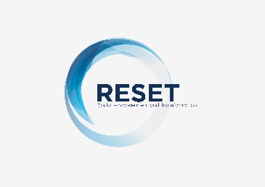


This project has been funded with support from the European Commission.

This publication reflects the views only of the author, and the Commission cannot be held responsible for any use which may be made of the information contained therein

